./

Learning Report – TDLC

Course Code: <CODE>



|  |  |  |  |  |  |
| --- | --- | --- | --- | --- | --- |
| **Ver. Rel. No.** | **Release Date** | **Prepared. By** | **Reviewed By** | **Approved By** | **Remarks/Revision Details** |
|  |  | Pranshi Lodha |  |  |  |
|  |  |  |  |  |  |
|  |  |  |  |  |  |
|  |  |  |  |  |  |
|  |  |  |  |  |  |

**Document History**

# 

## 

Contents

Activity 1 –Requirements Issue 4

Activity 2 – Checking Code Quality 5

Activity 3 – Checking the Implementation of the Code 6

Activity 4 – Solving of Issues 7

## 

## **Activity 1** –Requirements Issue

Task: Revisiting the requirements mentioned in the SDLC Calculator Project and comparing it with the implementation and raising issues if the requirements are not met.

Outcome: The requirements were checked and the corresponding issues were raised

## **Activity 2** – Checking Code Quality

Task: Explicit information on Code quality

Outcome: The code quality was checked using Codecy and the badge was obtained.



## 

## **Activity 3** – Checking the Implementation of the Code

Task: Checking the implementation of code by breaking the code and running the make file.

Outcome: Checking whether the functions mentioned in the requirements were implemented and then the corresponding issues were raised.

## **Activity 4** – Solving of Issues

Task: The issues raised within the team and the peer review to be closed in the GitHub repository.

Outcome: The issues were labelled as High, Medium and Low based on the priorities. Most of the issues were resolved and the issues were closed. The readme file was updated.

Total No. of Issues raised: 63 issues

No. of issues closed: 59 issues

No. of issues yet to be solved or to be done in future: 4 issues

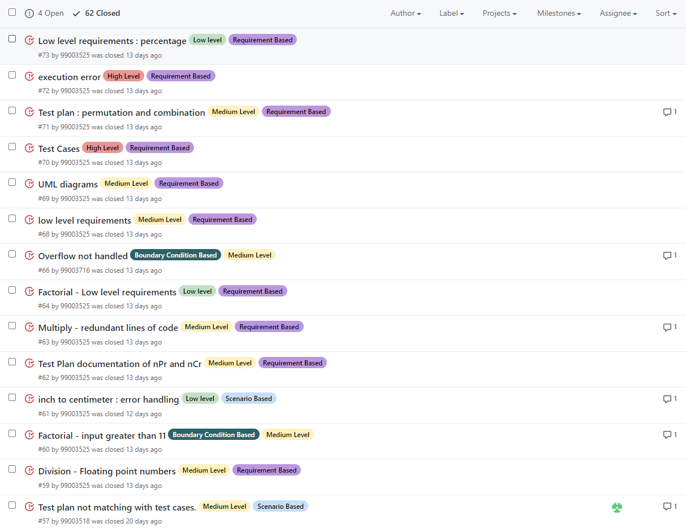

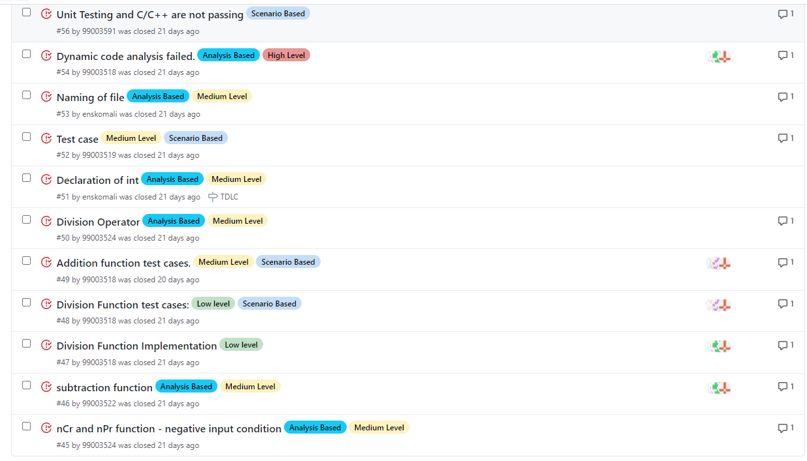

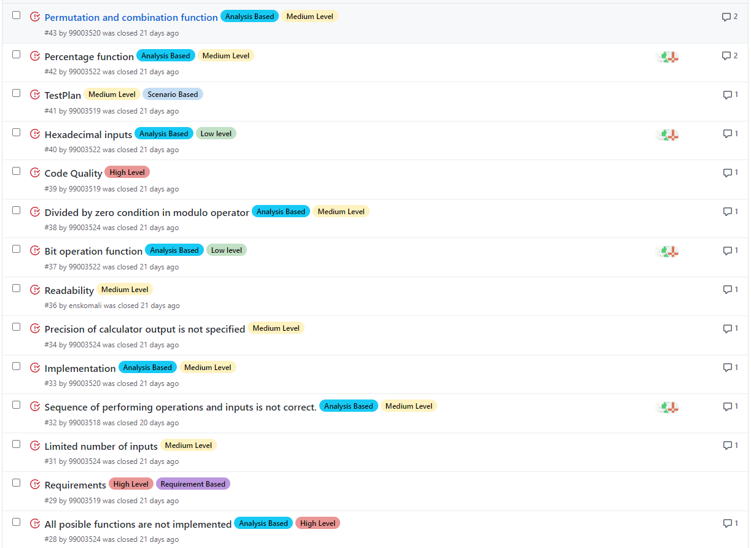

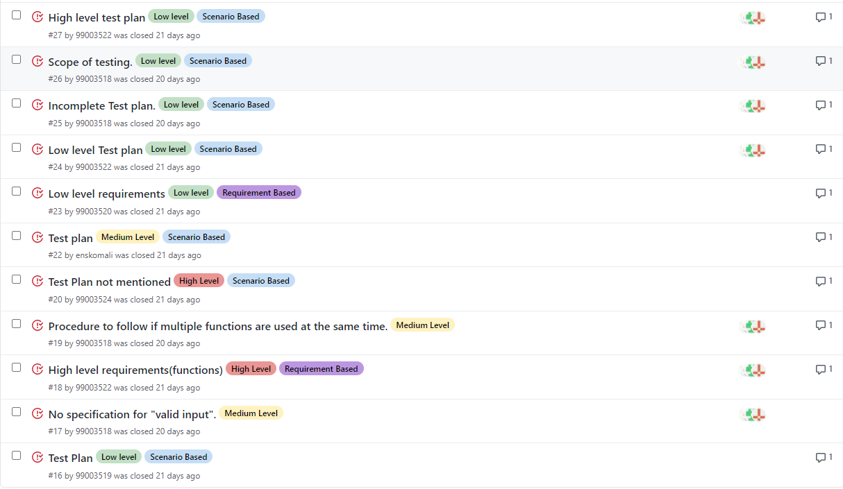

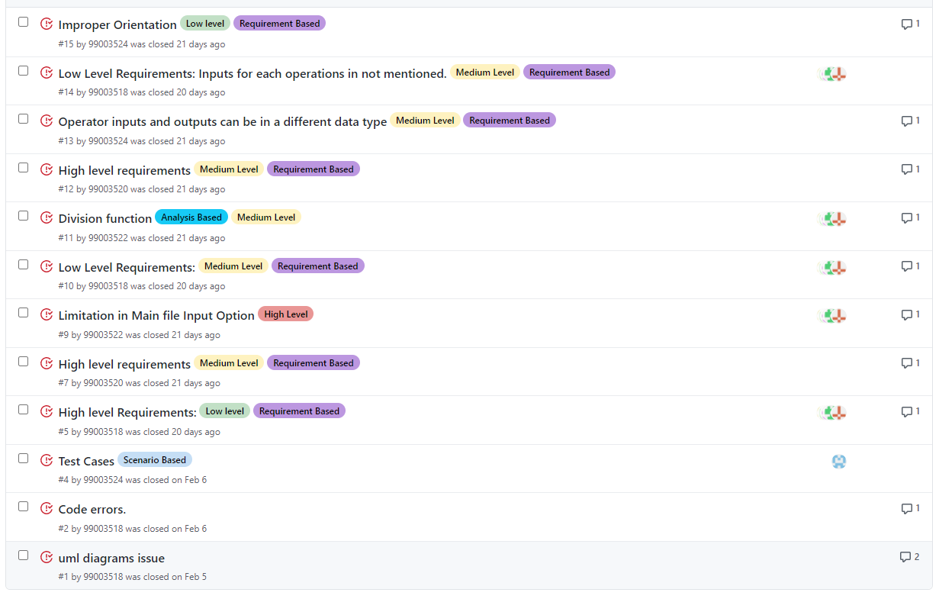

Issues Closed (59 issues)

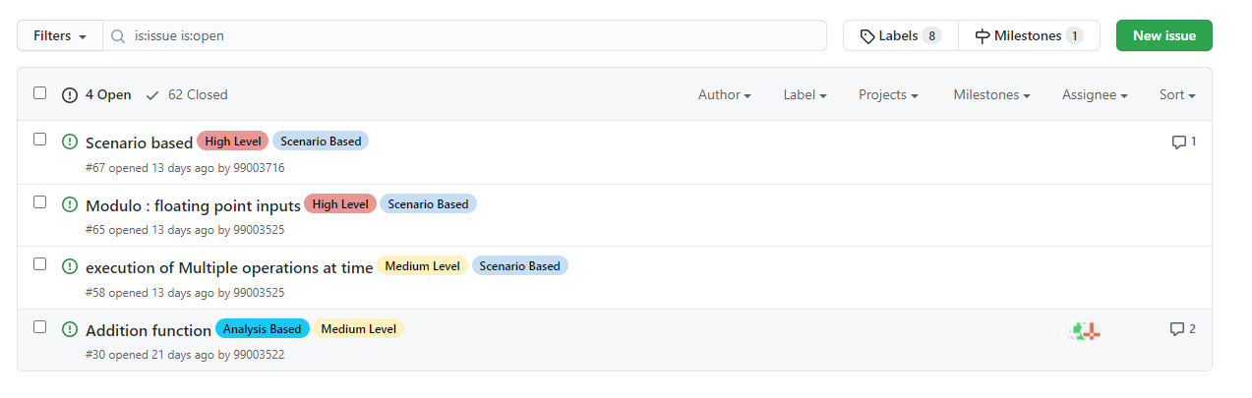

Issues Yet to be Closed (4 issues)

GitHub link: https://github.com/99003518/Team2_calciapp